Student Management System Using Django

1. Introduction
The Student Management System is a web-based application developed using the Django framework. The system provides basic CRUD (Create, Read, Update, and Delete) functionalities to manage student records. Each student record includes personal and academic information such as name, sex, address, course, and result. The system is designed to be simple, user-friendly, and suitable for academic institutions.

2. System Requirements

2.1 Hardware Requirements
- Computer with 4 GB RAM
- At least 500 GB free disk space

2.2 System Requirements and Functionality Environment
The Student Management System was developed and tested under the following environment and software specifications to ensure smooth operation and compatibility:

2.2.1. Operating System
Windows 10: The system was deployed and tested on Windows 10, providing compatibility with the Python runtime and Django framework.

2.2.2. Python
Python Version 3.6.2: The system requires Python 3.6.2, which supports all Django 3.2.25 features and libraries used in this project, including virtual environments and package management through pip.

2.2.3. Django
Django Version 3.2.25: This version was used to implement the web-based Student Management System. It provides the MVT (Model–View–Template) architecture for managing models, views, templates, and URL routing.

2.2.4. Web Browser
Google Chrome or Equivalent: The system is tested on modern web browsers that support HTML5, CSS3, and JavaScript for the front-end rendering of templates and interaction with the web application.

2.2.5. Code Editor
Visual Studio Code (Recommended): VS Code was used for writing, debugging, and managing project files. It offers integration with Python, Django extensions, and terminal commands to run the development server efficiently.

3. Project Structure
Yihun_Project/
│
├── Yihun_Project/
│ ├── __init__.py
│ ├── asgi.py
│ ├── settings.py
│ ├── urls.py
│ └── wsgi.py
│
├── crud_student/
│ ├── migrations/
│ │ └── __init__.py
│ ├── __init__.py
│ ├── admin.py
│ ├── apps.py
│ ├── models.py
│ ├── views.py ← delete student implemented here
│ ├── urls.py ← delete student URL defined here
│ └── templates/
│ └── crud_student/
│ ├── home.html
│ ├── add_student.html
│ ├── update_student.html
│ └── delete_student.html ← confirmation page
│
├── env/
├── manage.py
└── db.sqlite3

4. Navigate to Our Workspace
Open a command prompt and move to the directory where you want to create the project:
- cd C:\Users\A\Desktop\Yihun\ Yihun_Project
This ensures all project files are organized in a dedicated folder. Keeping projects organized improves maintainability and reduces confusion when managing multiple projects.

5. Create a Virtual Environment
A virtual environment was created to isolate the project dependencies from the global Python installation. This approach ensures version consistency, prevents dependency conflicts, and improves project portability.
python -m venv env
.\env\Scripts\activate.bat
Explanation:
- python -m venv env creates a virtual environment named env specifically for this project.
- .\env\Scripts\activate.bat activates the environment on Windows.
- Using a virtual environment ensures project dependencies do not conflict with globally installed packages and allows version control of packages.

6. Install Django
After activating the virtual environment, the Django web framework was installed within the virtual environment:
pip install django==3.2.25
- Django version 3.2.25 was selected due to its stability and long-term support.
- The framework provides built-in features such as URL routing, ORM, template engine, and security mechanisms, which simplify web application development.

7. Creating the Django Project
This section describes the step-by-step process followed to initialize and prepare the Django project environment for the development of the Student Management System. Initialize the main project:
django-admin startproject Yihun_Project
cd Yihun_Project
Explanation:
- startproject generates the main project structure containing:
- The project includes essential configuration files such as:
  - settings.py → Global project settings configuration (database, installed apps, templates, etc.)
  - urls.py → Root URL routing configuration
  - wsgi.py → Web Server Gateway deployment Interface for deployment
- The directory was entered using cd Yihun_Project to continue development tasks.

8. Create the Application Module
A Django application was created to encapsulate all student management functionalities.
python manage.py startapp crud_student
Explanation:
- The crud_student app handles student data processing and presentation.
- This modular approach improves maintainability and supports system scalability.

9. Configure the Project
Project configuration ensures that Django recognizes the created application and properly manages static files, templates, and database interactions.
To enable the application within the project, it was registered in the INSTALLED_APPS section of settings.py.
INSTALLED_APPS = [
...
'crud_student',
]
Registering the app allows Django to detect models, templates, and migrations associated with the application.

10. Design the Database Model
The database layer was designed using Django’s Object-Relational Mapping (ORM) system, which simplifies database interaction without writing raw SQL queries. Define the Student model in crud_student/models.py:

11. Apply Database Migrations
After defining the model, database migrations were performed to translate the model structure into actual database tables. Generate and apply database migrations:
python manage.py makemigrations
python manage.py migrate
Explanation:
- makemigrations generates migration files based on model definitions.
- migrate applies these changes to the database.
- This process ensures synchronization between the model and the database schema.

12: Configure URLs
URL configuration defines how HTTP requests are mapped to application views.

12.1 Application URL Configuration
The app-level URL routing was defined in crud_student/urls.py.
from django.urls import path
from . import views
urlpatterns = [
path('', views.home, name='home'),
path('add/', views.add_student, name='add_student'),
path('update/<int:id>/', views.update_student, name='update_student'),
path('delete/<int:id>/', views.delete_student, name='delete_student'),
]
Explanation:
- Maps HTTP requests to specific view functions.
- <int:id> allows operations on specific student records.
- Named URLs (name='...') make referencing in templates and redirects easier.

12.2 Project URLs
Include the app URLs in Yihun_Project/urls.py:
from django.contrib import admin
from django.urls import path, include

urlpatterns = [
path('admin/', admin.site.urls),
path('', include('crud_student.urls')),
]
Explanation:
- The project URLs delegate routing to the app’s URLs.
- Centralizes all URL configurations while keeping app-level URLs modular.

13. Run the Development Server
Start the Django server:
python manage.py runserver
Explanation:
- The server runs locally at http://127.0.0.1:8000/.
- The system can now be tested in a web browser.

Sample Working Interfaces

Home Page:
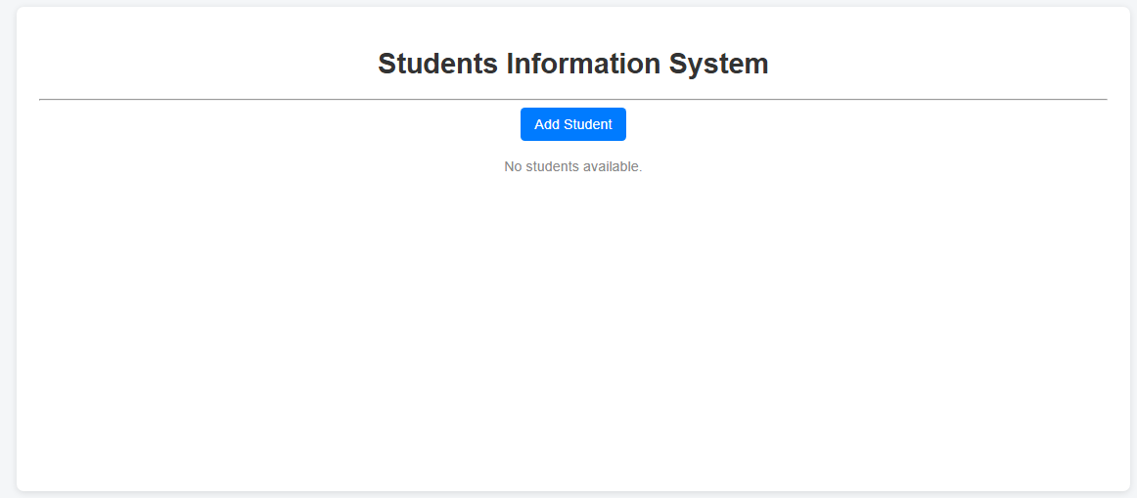

Add Student Information Page:
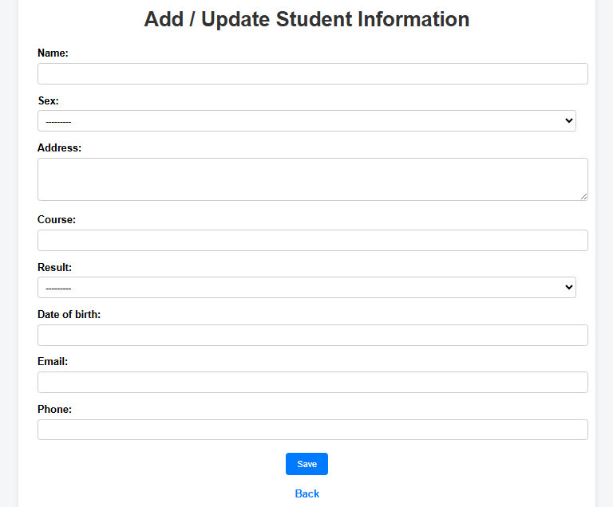

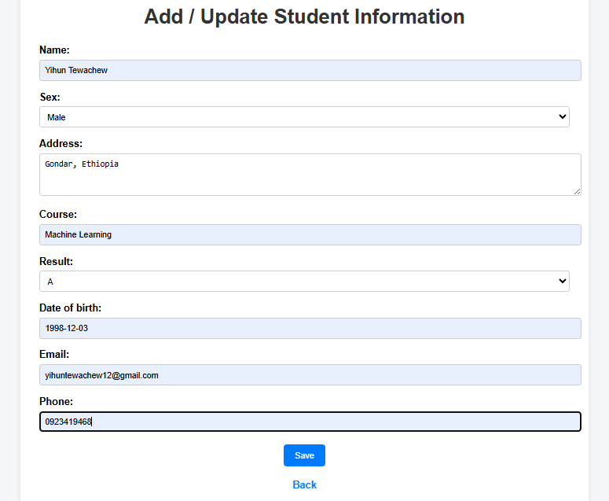

View Student Information Page:
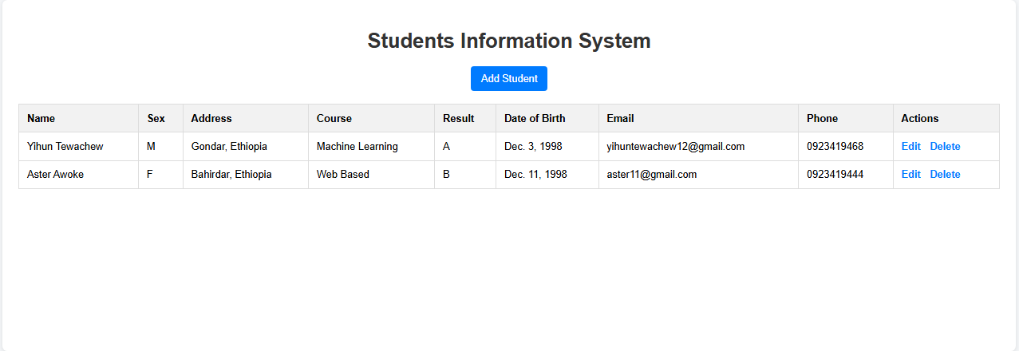

Delete Student Information Page:
